[ 붙임.Attachment #2 ]

한국어연수 학비 환불신청서
(Application for Tuition Refund)
▣ 환불신청자（Applicant）
*이 름 (Name in Full)
*생년월일(Date of Birth)
*여권번호(Passport No.)

▣ 환불은행 정보（Bank Info.）
*은 행 명 (Bank Name)
*계좌번호 (Account No. )
*예금주 (Account Holder)
*SWIFT CODE | 한국내 은행은 기재 불필요(N/A for Korean Banks)
*은행주소 (Bank Address) | 한국내 은행은 기재 불필요(N/A for Korean Banks)

▣ 위임장（Power of Attorney）
본인은 인천대학교 한국어연수과정 등록금 환불 건에 대해 다음 사람에게 위임합니다.
(I hereby appoint the afore-mentioned person, as my attorney-in-fact, to receive the tuition for the Korean Language Program at Incheon National University)
*피위임인(Attorney) 이름(Name) : *생년월일(Date of Birth) :
▣ 환불사유 (Reason for Refund)

I hereby apply for the refund of tuition for the Korean Language Program at Incheon National University.
( 본인은 인천대학교 한국어연수 프로그램에 대한 등록금 환불신청서를 제출합니다. )

DATE(YYYY/MM/DD) : 201 . . . Applicant : (Signature of Applicant)

▣ Required Documents (첨부서류)
① 통장사본(Photocopy of bank book)
② 비자취소사유서(Reason for Visa Rejection) issued by Korean Embassy/Consulate(한국대사관/영사관 발행) or (또는) 표준입학허가서 원본(Original copy of Certificate of Admission issued by Incheon National University)
③ 위임시 피위임인 신분증 및 통장 복사본 (Photocopy of Appointee's ID card and bank book )
※Please send refund application with required documents as below as soon as your visa is rejected.
(비자 취소시 조속히 환불신청서를 보내주시기 바랍니다.) E-mail : inukli@inu.ac.kr / Fax : +82-32-835-0735

[ 붙임.Attachment #2 ] SAMPLE

한국어연수 학비 환불신청서 (SAMPLE FORM)
(Application for Tuition Refund)
▣ 환불신청자（Applicant）
*이 름 (Name in Full) | MUNKHDORJ ENKHJARGAL
*생년월일(Date of Birth) | Sept 08, 1995
*여권번호(Passport No.) | E1234567

▣ 환불은행 정보（Bank Info.）
*은 행 명 (Bank Name) | 농협은행
*계좌번호 (Account No. ) | 123 – 01 - 456789
*예금주 (Account Holder) | BILGUUN UYANGA
*SWIFT CODE | 한국내 은행은 기재 불필요(N/A for Korean Banks)
*은행주소 (Bank Address) | 한국내 은행은 기재 불필요(N/A for Korean Banks)

▣ 위임장（Power of Attorney）
본인은 인천대학교 한국어연수과정 등록금 환불 건에 대해 다음 사람에게 위임합니다.
(I hereby appoint the afore-mentioned person, as my attorney-in-fact, to receive the tuition for the Korean Language Program at Incheon National University)
*피위임인(Attorney) 이름(Name) : BILGUUN UYANGA *생년월일(Date of Birth) : July 01, 1991
▣ 환불사유 (Reason for Refund)
비자발급 거부

I hereby apply for the refund of tuition for the Korean Language Program at Incheon National University.
( 본인은 인천대학교 한국어연수 프로그램에 대한 등록금 환불신청서를 제출합니다. )

DATE(YYYY/MM/DD) : 2015 .04. 22. Applicant : MUNKHDORJ ENKHJARGAL

▣ Required Documents (첨부서류)
① 통장사본(Photocopy of bank book)
② 비자취소사유서(Reason for Visa Rejection) issued by Korean Embassy/Consulate(한국대사관/영사관 발행) or (또는) 표준입학허가서 원본(Original copy of Certificate of Admission issued by Incheon National University)
③ 위임시 피위임인 신분증 및 통장 복사본 (Photocopy of Appointee's ID card and bank book )
※Please send refund application with required documents as below as soon as your visa is rejected.
(비자 취소시 조속히 환불신청서를 보내주시기 바랍니다.) E-mail : inukli@inu.ac.kr / Fax : +82-32-835-0735

▣ Required Documents (첨부서류)
1. 통장사본(Photocopy of bank book)
3. 위임시 피위임인 신분증 및 통장 복사본(Photocopy of Appointee's ID card and bank book )

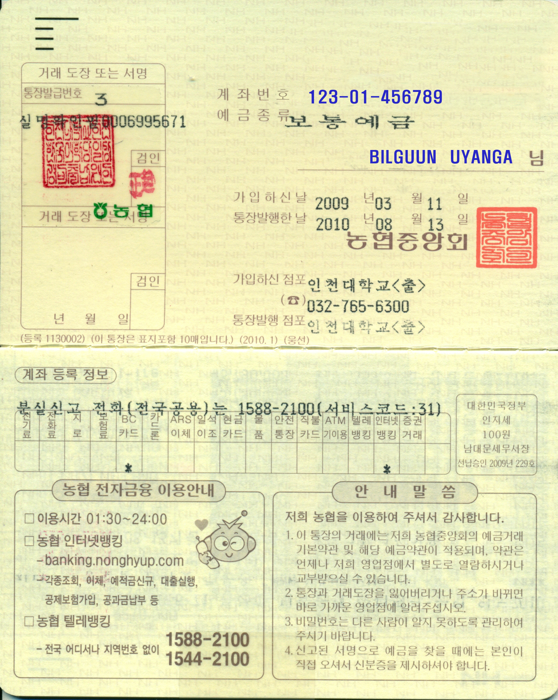 | 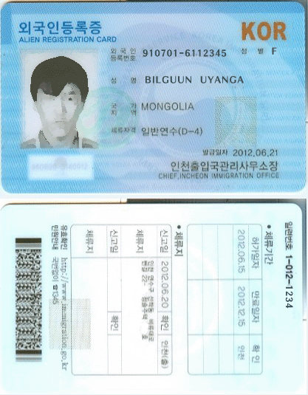

▣ Required Documents (첨부서류)  2. 비자취소사유서(Reason for Visa Rejection) issued by Korean Embassy/Consulate(한국대사관/영사관 발행) or (또는) 표준입학허가서 원본(Original copy of Certificate of Admission issued by Incheon National University )  비자 거절시 대사관(영사관)에서 발급하는  서류(혹은 비슷한 양식)를  반드시 제출하여 주셔야 합니다. | 